**IV- CONCLUSION AND RECOMMENDATIONS**

This chapter presents the conclusions and recommendations of which are derived from the findings of this study.

**Conclusions**

Based on the conclusions of the study, the following conclusions were drawn.

1. The existing materials that are used in teaching the topic Solar System and the universe are Audio Visual Presentations, PowerPoint Presentation and books. Classes are conducted via Google Meet. Further, their program has two schedules which are synchronous in the morning and asynchronous in the afternoon.
2. The proposed mobile application with the features Integration of e-Lessons, Virtual Reality Multimedia Section and Virtual Reality Quiz will serve as an additional learning material to the grade 6 students of Panpacific University North Philippines
3. The mobile application is Highly Accepted to the user acceptability with an average of 3.45 weighted mean and Accepted to the system acceptability with an average weighted mean (AWM) of 2.95.

**Recommendations**

1. The proponents recommends to the future researchers to add an educational game on the application.
2. The proponents recommends to make the application available not only on Android Operating Systems but also on Apple Operating Systems as well.
3. The proponents recommends to the future researchers to add more lessons and quizzes.

**References**

[1] R. Raja, P. C. Nagasubramani “Impact of modern technology in education” May 2018

Retreived From:

<https://www.researchgate.net/publication/325086709_Impact_of_modern_technology_in_education>

[2]  Angeliki Apergi, Angeliki Anagnostopoulou, Alexandra Athanasiou “E-Learning for Elementary Students: The Web 2.0 Tool Google Drive as Teaching and Learning Practice” April 2015

Retreived From:

<https://www.researchgate.net/publication/276156367_E-Learning_for_Elementary_Students_The_Web_20_Tool_Google_Drive_as_Teaching_and_Learning_Practice>

[3] Sander Tamm “What is e-learning?” December 21, 2019

Retrieved from:

<https://e-student.org/what-is-e-learning/>

[4] Association for talent developer  “What is e-learning?”

Retrieved From:

<https://www.td.org/talent-development-glossary-terms/what-is-e-learning>

[5] A. Pauline Chitra and M. Antoney Raj “E-Learning” May 2018

Retrieved from:

<https://www.researchgate.net/publication/325086405_E-Learning>

[6] Cory Mitchell “Virtual Reality” September 29, 2020

Retrieved from:

<https://www.investopedia.com/terms/v/virtual-reality.asp>

[7] Irusu “Virtual Reality in Education 2020:7 Important Benefits

Retrieved From:

<https://irusu.co.in/virtual-reality-vr-in-education-2020-7-important-benefits/#:~:text=Virtual%20reality%20(VR)%20in%20education,user%20experience%20that%20feels%20real>.

[8] Formplus Blog “ What is Applied Research? + [Types, Examples & Method]”  December 7

Retrieved From:

<https://www.formpl.us/blog/applied-research#:~:text=Applied%20research%20is%20a%20type,an%20individual%2C%20group%20or%20society.&text=Applied%20research%20is%20sometimes%20considered,a%20solution%20to%20a%20problem>.

[9] Tutorialspoint “SDLC RAD Model”

Retrieved From:

<https://www.tutorialspoint.com/sdlc/sdlc_rad_model.htm>

[10] Ankita Singh “What Is Rapid Application Development (RAD)?” Published Dec. 06, 2019

Retrieved from:

<https://blog.capterra.com/what-is-rapid-application-development/>

[11] Lucidchart Content Team “4 Phases of Rapid Application Development Methodology”

Retrieved from :

<https://www.lucidchart.com/blog/rapid-application-development-methodology>

[12] QuestionPro “Online Surveys: Definition, Characteristics, Examples, Advantages and Disadvantages”

Retrieved from:

<https://www.questionpro.com/blog/what-are-online-surveys/>

**Appendix A**

**User Acceptability Questionnaire**

Title of software package/program: **SOLREI: THE UNIVERSE AND THE SOLAR SYSTEM, A VIRTUAL E-LEARNING MOBILE APPLICATION**

Direction: Please evaluate the software based on the given criteria:

4 – Highly Accepted 2 – Moderately Accepted

3 – Accepted 1 – Not Accepted

|  |  |  |
| --- | --- | --- |
| Description | Weighted Mean | Descriptive Equivalent |
| The learning objectives are clearly stated in each category |  |  |
| The scope of the lesson is clearly stated |  |  |
| The organization of each category is easy to follow |  |  |
| The structure keeps me focused on what is to be learned. |  |  |
| The problem is clearly stated in my subject |  |  |
| Activities are planned carefully |  |  |
| The program content is easy to understand |  |  |
| The presentation of the subject content is clear |  |  |
| The program originality and creativity in the visual design and layout |  |  |
| The colors used in the program is appropriate |  |  |
| The multimedia technology (example: graphics, sound) contributes to the affective appeal of the program |  |  |
| I enjoy learning in this program |  |  |
| I felt a sense of satisfaction and achievement about this program |  |  |
| Learning to operate the program was easy |  |  |
| I was able to access the program materials without much difficulty |  |  |

Evaluator:

Date of evaluation:

**Appendix B**

**System Acceptability Questionnaire**

Title of software package/program: **SOLREI: THE UNIVERSE AND THE SOLAR SYSTEM, A VIRTUAL E-LEARNING MOBILE APPLICATION**

Direction: Please evaluate the software based on the given criteria:

4 – Highly Accepted 2 – Moderately Accepted

3 – Accepted 1 – Not Accepted

|  |  |  |  |  |
| --- | --- | --- | --- | --- |
| **Indicators** | 4 | 3 | 2 | 1 |
| **Functionality** |  |  |  |  |
| The program is easy to start and close. |  |  |  |  |
| Accuracy of data/information. |  |  |  |  |
| It is easy to navigate through the program. |  |  |  |  |
| The icons are clear and intelligible for easy use and navigation. |  |  |  |  |
| **Reliability** |  |  |  |  |
| The grammar and the vocabulary used in the program is correct |  |  |  |  |
| The program has unique identity (example: logo) |  |  |  |  |
| **Usability** |  |  |  |  |
| The system contents can be easily understood by the users. |  |  |  |  |
| The features of the system are easy to learn and are adoptable to the users |  |  |  |  |
| The system has a user-friendly interface. |  |  |  |  |
| The program is open for support and maintenance. |  |  |  |  |
| The program is usable |  |  |  |  |

Evaluator:

Date of evaluation:

**Appendix C**

Letter for the Administration

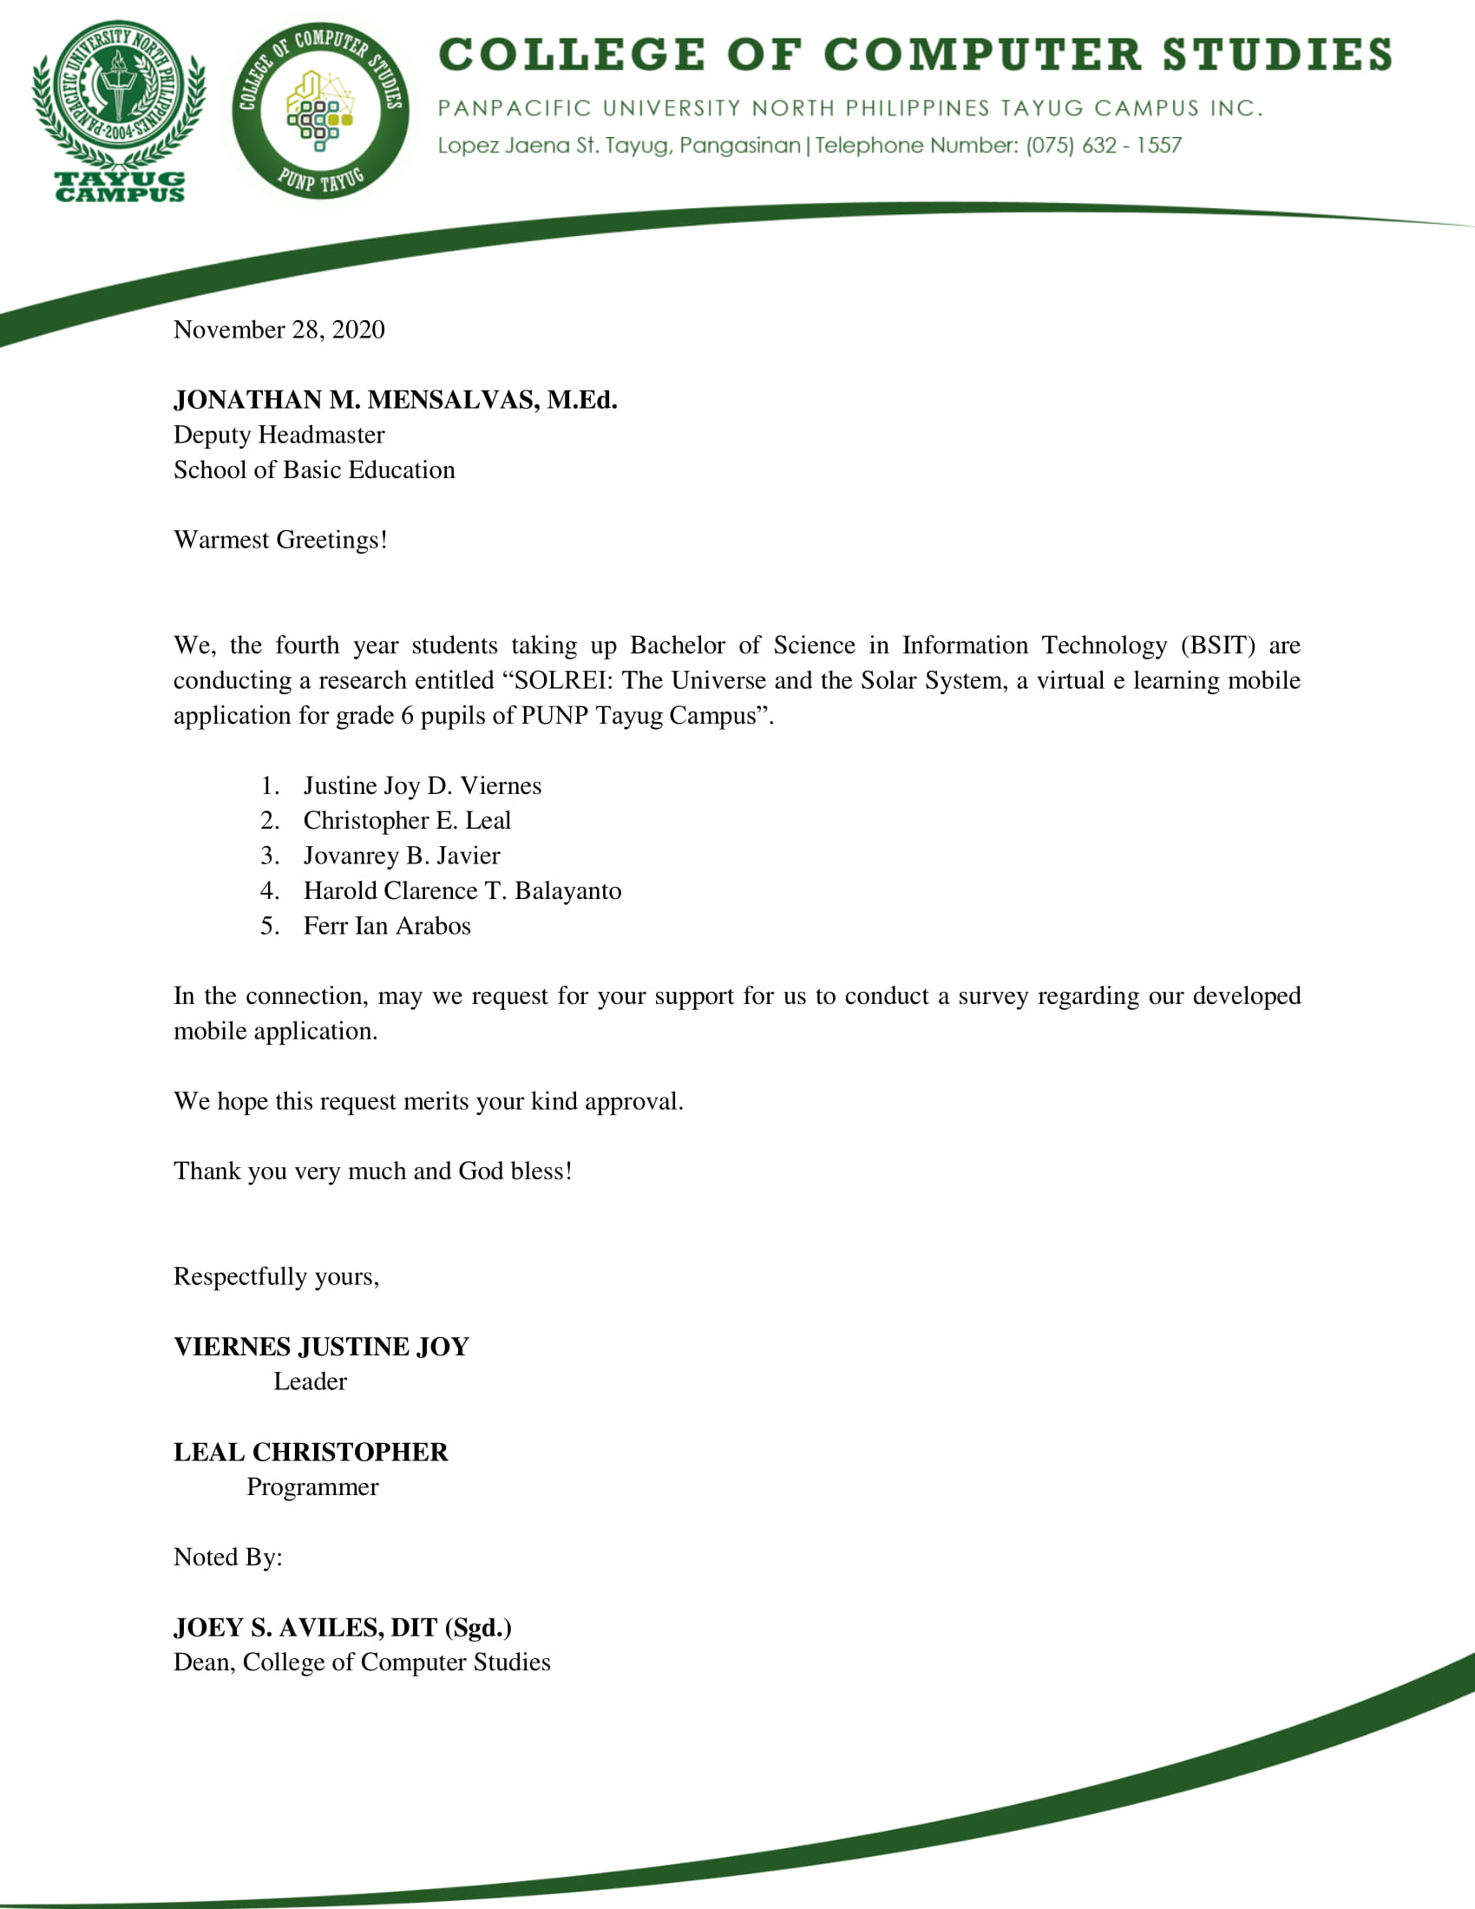

**Appendix D**

Questionnaire for the Teacher-in-Charge in teaching the Topic Solar System and The Universe

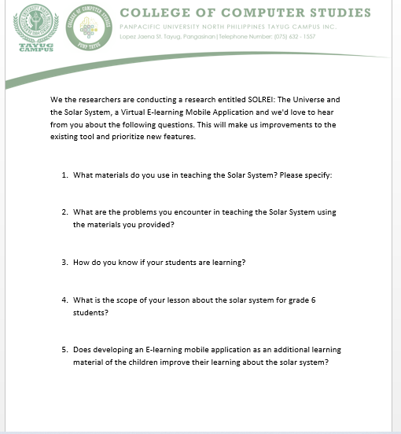

**Appendix E**

Response of the Teacher-in-Charge in the questionnaire given

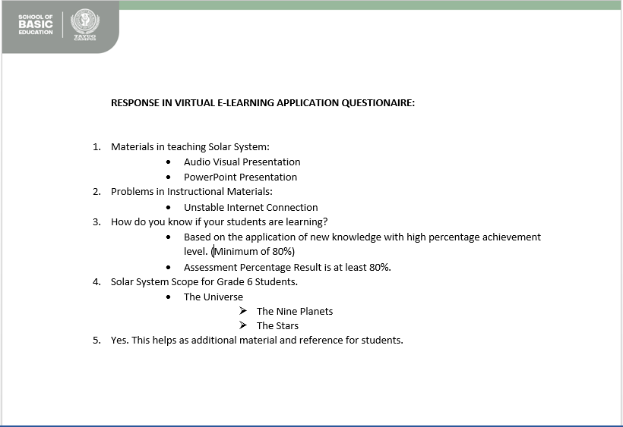

**Appendix F**

Follow Up Questions for the Teacher-in-Charge

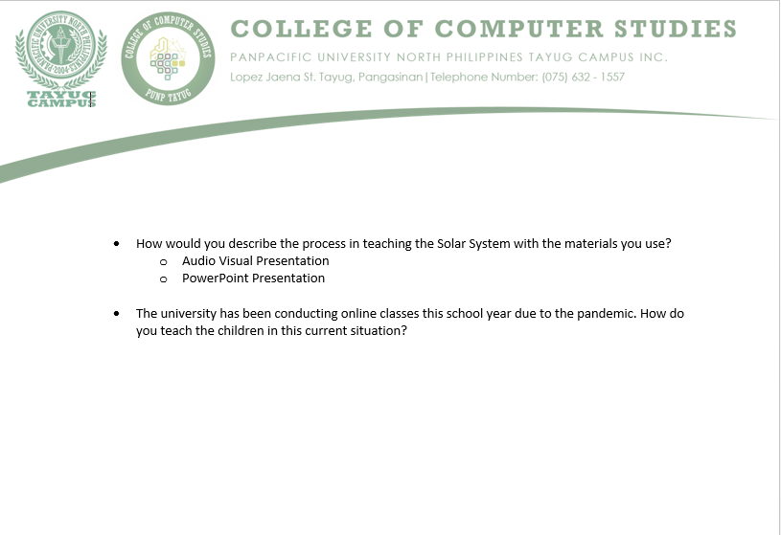

**Appendix G**

Response of the Teacher-in-charge in the follow up questions

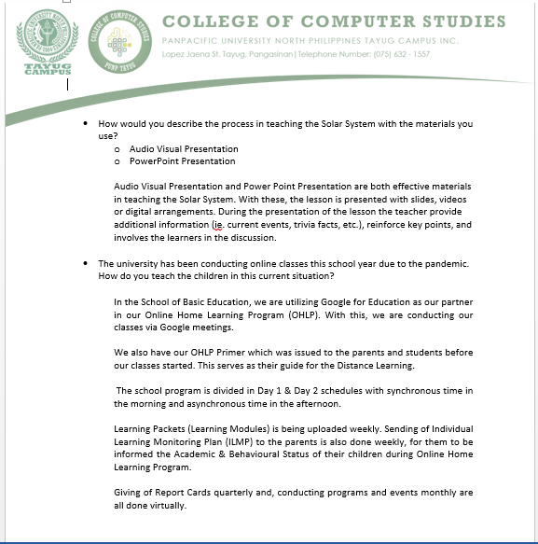

**Appendix H**

Letter for conducting an evaluation for User Acceptability Test

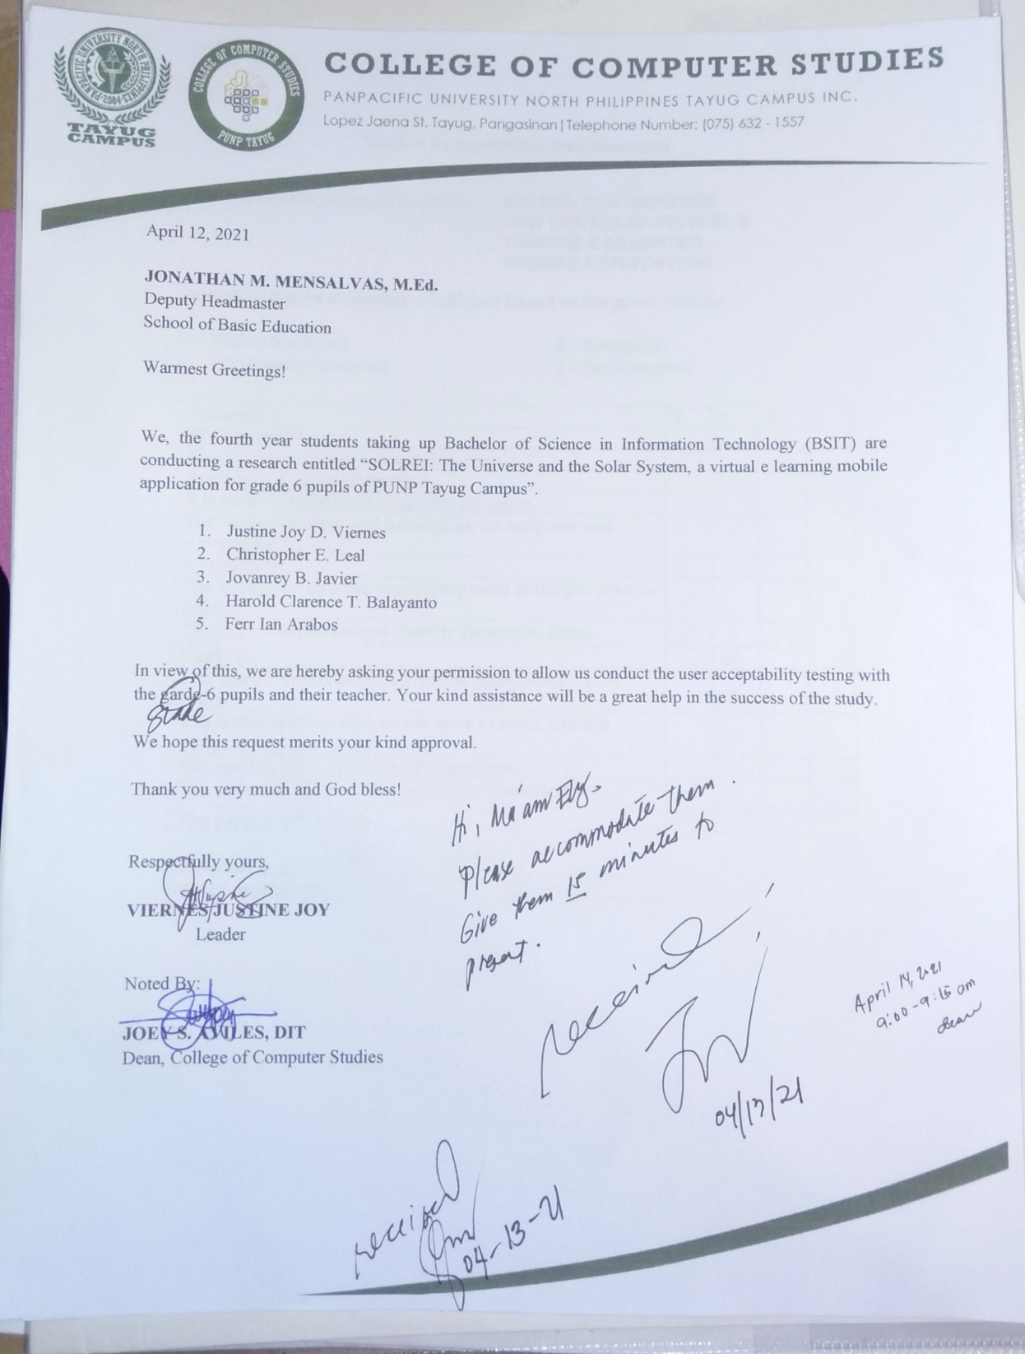

**Curriculum Vitae**

Justine Joy D. Viernes

#88 Mabini St. Barangay A. Tayug, Pangasinan

09951642607

[tinejfriday@gmail.com](mailto:tinejfriday@gmail.com)



|  |  |
| --- | --- |
| Age: | 22 |
| Date of Birth: | August 8, 1998 |
| Father’s Name: | Rodulfo M. Viernes Jr. |
| Mother’s Name | Vivian D. Viernes |
| Civil Status: | Single |
| Religious Affiliation: | Roman Catholic |
| Nationality: | Filipino |
| Hobbies and Interests: | Watching K-Drama, Reading |

**Personal Information:**

**Educational Background:**

Tertiary Education: Bachelor of Science in Information Technology

Panpacific University North Philippines

Lopez Jaena St. Tayug, Pangasinan

Secondary Education: Eastern Pangasinan Agricultural College

Sta. Maria, Pangasinan

Elementary Education: San Vicente Elementary School

San Vicente Sta. Maria Pangasinan

**Trainings and Seminars Attended:**

Regional Assembly on Information Technology Education 2019-

“Gamified IT Education Gen Zers Newest Learning Platform

September 6, 2019 @ Mariveles, Bataan

ProjProject ROMEO: A Management and Workshop Training

Camp Avenue San Jun La Union

November 27-28, 2018

**Curriculum Vitae**



Harold Clarence T. Balayanto

Barangay Poblacion West Natividad, Pangasinan

09186254634

clarencebalayanto@gmail.com

**­­­­­­­­­**

|  |  |
| --- | --- |
| Age: | 21 |
| Date of Birth: | May 9. 1999 |
| Father’s Name: | Arnold R. Balayanto |
| Mother’s Name | Elvie T. Balayanto |
| Civil Status: | Single |
| Religious Affiliation: | Christian |
| Nationality: | Filipino |
| Hobbies and Interests: | Playing Basketball and watching movies |

**Personal Information:**

**Educational Background:**

Tertiary Education: Bachelor of Science in Information Technology

Panpacific University North Philippines

Lopez Jaena St. Tayug, Pangasinan

Secondary Education: Kapitolyo High School

San. Ignacio St. Kapitolyo, Pasig City

Elementary Education: Oranbo Elementary School

St. Agustine Street. Oranbo Pasig City

**Work Experience:**

* SPES (Special Program for the Employment of Students) March – April 2015 Encoder (Barangay Oranbo Health Center Pasig City)

**Curriculum Vitae**



Ferr Ian G. Arabos

Sitio Luarca Barangay Poblacion East Natividad, Pangasinan

09661582985

ferrian.arabos@gmail.com

|  |  |
| --- | --- |
| Age: | 23 |
| Date of Birth: | November 15, 1997 |
| Father’s Name: | Sonny G. Arabos |
| Mother’s Name | Edna G. Arabos |
| Civil Status: | Single |
| Religious Affiliation: | Roman Catholic |
| Nationality: | Filipino |
| Hobbies and Interests: | Playing Online Games and watching movies |

**Personal Information:**

**Educational Background:**

Tertiary Education: Bachelor of Science in Information Technology

Panpacific University North Philippines

Lopez Jaena St. Tayug, Pangasinan

Secondary Education: Natividad National High School

Natividad, Pangasinan

Elementary Education: Natividad Central School

Natividad, Pangasinan

**Trainings and Seminars Attended:**

Regional Assembly on Information Technology Education 2019-

“Gamified IT Education Gen Zers Newest Learning Platform

September 6, 2019 @ Mariveles, Bataan

Training the Resilient & Optimistic On-The-Job Training to Perform and Succeed (TROOPS) 2017

**Curriculum Vitae**

Cristopher E. Leal

#31 Figueroa St. Brgy. Cabalaoangan San Quintin, Pangasinan

09664021995

leal.crstphr@gmail.com

|  |  |
| --- | --- |
| Age: | 21 |
| Date of Birth: | July 3, 1999 |
| Father’s Name: | Freddie P. Leal |
| Mother’s Name | Vilma E. Leal |
| Civil Status: | Single |
| Religious Affiliation: | Roman Catholic |
| Nationality: | Filipino |
| Hobbies and Interests: | Watching movies, creating graphic arts and designs |

**Personal Information:**

**Educational Background:**

Tertiary Education: Bachelor of Science in Information Technology

Panpacific University North Philippines

Lopez Jaena St. Tayug, Pangasinan

Secondary Education: San Quintin National High School

Casantamaria-an San Quintin, Pangasinan

Elementary Education: Cabalaoangan Elementary School

Cabalaoangan San Quintin, Pangasinan

**Trainings and Seminars Attended**

Regional Assembly on Information Technology Education 2019-

“Gamified IT Education Gen Zers Newest Learning Platform

September 6, 2019 @ Mariveles, Bataan

**Curriculum Vitae**



Jovanrey B. Javier

Purok 5 San Eugenio, Natividad, Pangasinan

09950380089

javierjovanrey@gmail.com

|  |  |
| --- | --- |
| Age: | 24 |
| Date of Birth: | May 30, 1996 |
| Father’s Name: | Jojo D. Javier |
| Mother’s Name | Evangeline V. Bibat |
| Civil Status: | Single |
| Religious Affiliation: | Roman Catholic |
| Nationality: | Filipino |
| Hobbies and Interests: | Photography, Biking, Graphic Designer and Multimedia |

**Personal Information:**

**Educational Background:**

Tertiary Education: Bachelor of Science in Information Technology

Panpacific University North Philippines

Lopez Jaena St. Tayug, Pangasinan

Secondary Education: Salud-San Eugenio National High School

Salud Natividad, Pangasinan

Elementary Education: San Eugenio Elementary School

San Eugenio Natividad, Pangasinan

**Trainings and Seminars Attended:**

Regional Assembly on Information Technology Education 2019-

“Gamified IT Education Gen Zers Newest Learning Platform

September 6, 2019 @ Mariveles, Bataan

Project ROMEO: A Management and Workshop Training

Camp Avenue San Jun La Union

November 27-28, 2018